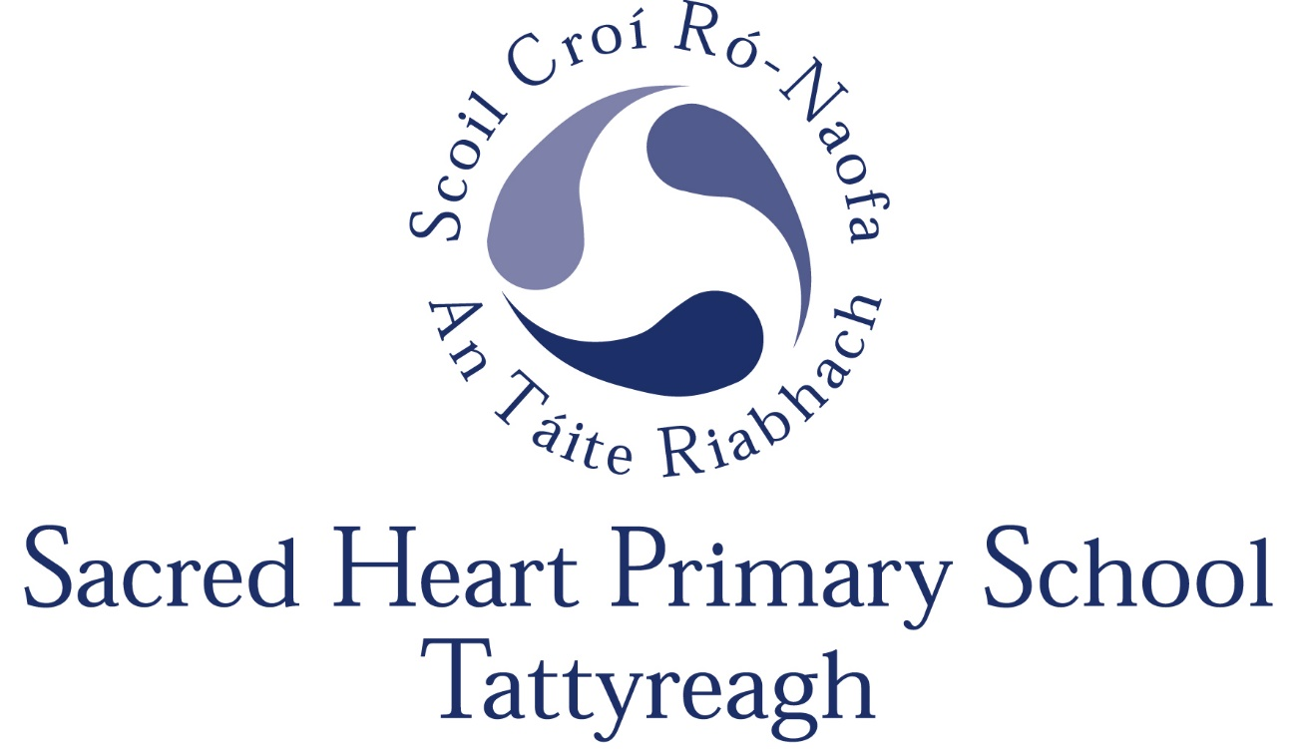

Relationships & Sexuality Policy

Signed: _____________________________________BOG Chair

____________________________________ Principal

Date: _______________________

Review date: _________________

Relationships and Sexuality Education in the N.I. context

RSE is not a new area of the curriculum. The framework for sex education was initially established by the Department of Education for Northern Ireland (DENI) in a Guidance Circular 1987/45. The main recommendation of this Circular was that each school should have a written policy on sex education which is endorsed by staff and governors and communicated to parents. It also stated “sex education should be taught in a sensitive manner which is in harmony with the ethos of the school and in conformity with the moral and religious principles held by parents and school management
authorities”

The Education Reform (Northern Ireland) Order 1989 further set out the legislative basis, requiring all grant aided schools to offer a curriculum which:

- promotes the spiritual, moral, cultural, intellectual and physical development of pupils at the school and thereby of society …and…

- prepares such pupils for the opportunities, responsibilities and experiences of adult life

The general principles which underpin our work are those set out in Departmental guidance and the following Circulars:

Circular 2001/15: Relationships and Sexuality Education (RSE)
Circular 2001/15-2: Guidance for Primary Schools - Relationships and Sexuality Education (RSE)
Circular 2010/01: Guidance on Relationships and Sexuality Education (RSE)
Circular 2013/16: Relationships and Sexuality Education Policy in Schools

We further recognise the importance of working in partnership with parents/carers in this area of personal development and acknowledge the contribution that can be made by outside agencies with skill and expertise in particular areas of the curriculum (NSPCC, Women’s Aid and School Nursing Service).

INTRODUCTION

Relationships and Sexuality Education (RSE) is a lifelong process which encompasses the acquisition of knowledge, understanding and skills, and the development of attitudes, beliefs and values about personal and social relationships and gender issues. The learning process begins informally with our parents (or those holding parental responsibility) long before any formal education takes place at school.

RSE is included on a statutory basis within the NI curriculum through PDMU, Health Education, the World around Us and Religious Education. Health Education is taught mainly through the medium of PDMU in the Personal Understanding and Health strand as detailed later.
In RSE all pupils will be taught in an atmosphere of mutual respect. The value of a stable family life, marriage and the responsibilities of parenthood will be presented. As they mature, pupils will be encouraged to appreciate the importance of self-discipline, dignity, respect for themselves and others. Through PDMU and the World Around Us children will learn about changes in their bodies as they grow older and, in Y7, will be given the opportunity for a talk with the school nurse in order to prepare them fully for post-primary schools and the emotional and physical changes they may expect to experience over the next few years.

Teaching at all times will be appropriate to the maturity and level of understanding of the pupils concerned. Teachers will be aware of, and take into account, the variety of existing pupil knowledge, the different attitudes and beliefs and the pupil’s capacity to understand the issues.
Sexuality includes all aspects of the human person that relate to being male or female and is subject to change and development throughout life. Sexuality is an integral part of the human personality and has biological, cultural, psychological, social and spiritual dimensions. It especially concerns affectivity, the capacity to give and receive love; procreation and, in a more general way, the aptitude for forming relationships with others. It is a complex dimension of human life and relationships.

Teaching RSE should provide opportunities which enable pupils:
- to form values and establish behaviour within a moral, spiritual and social framework;
- to examine and explore the various relationships in their personal lives;
- to learn how to develop and enjoy personal relationships and friendships which are based on responsibility and mutual respect;
- to build the foundations for developing more personal relationships in later life;
- to make positive, responsible choices about themselves and others and the way they live their lives.

AIMS

The aims of RSE are to:
- enhance the personal development, self-esteem and well-being of the child;
- help the child develop healthy and respectful friendships and relationships;
- foster an understanding of, and a healthy attitude to, human sexuality and relationships in a moral, social and spiritual framework;
- promote responsible behaviour and the ability to make informed decisions;
- help the child come to value family life and marriage;
- appreciate the responsibilities of parenthood;
- promote an appreciation of the value of human life and the wonder of birth.

LEARNING OBJECTIVES

The RSE curriculum should enable pupils to:
- acquire and develop knowledge and understanding of self;
- develop a positive sense of self-awareness, self-esteem and self-worth;
- develop an appreciation of the dignity, uniqueness and well-being of others;
- understand the nature, growth and development of relationships within families, in friendships and

in wider contexts;
- develop an awareness of differing family patterns;
- develop strategies to make decisions, solve problems, and implement actions in various personal, social and health contexts;
- become aware of the variety of ways in which individuals grow and change and understand that their developing sexuality is an important aspect of self-identity;
- develop personal skills which will help to establish and sustain healthy personal relationships;
- develop some coping strategies to protect self and others from various forms of abuse;
- acquire and improve skills of communication and social interaction;
- acquire and use an appropriate vocabulary to discuss feelings, sexuality, growth and development;
- develop a critical understanding of external influences on lifestyles and decision making.

SKILLS

The RSE curriculum should enable pupils to develop the skills necessary to form and maintain relationships and to make informed choices and decisions regarding health and well-being.

Pupils should also be helped to develop skills to critically evaluate the wide range of information, opinions, attitudes and values. They need opportunities to develop:

- practical skills for everyday living; for supporting others; for future parenting;
- communication skills learning to listen, listening to others’ points of view; putting one’s own view forward clearly and appropriately; giving and receiving feedback; handling and resolving conflict peacefully; being assertive;
- decision-making and problem-solving skills for sensible choices made in the light of relevant information; making moral judgements about what to do in actual situations and putting these judgements into practice; acting responsibly and with initiative as an individual or as a member of a variety of groups;
- inter-personal skills for managing relationships confidently and effectively; for developing as an effective group member or leader.

MORALS AND VALUES

RSE should enable pupils to clarify what they believe and why they believe it and develop a respect for and interest in the beliefs of others. Pupils need opportunities to explore values and attitudes and to consider how they, and others, are affected by them.

The importance of a moral framework is emphasised in the DfEE Circular No 5/1994 Education Act 1993: Sex Education in Schools: “Sex education . . . must not be value-free; it should also be tailored not only to the age but also to the understanding of pupils. School’s programmes of sex education should therefore aim to present facts in an objective, balanced and sensitive manner, set within a clear framework of values and an awareness of the law on sexual behaviour. Pupils should accordingly be encouraged to appreciate the value of stable family life, marriage and the responsibilities of parenthood. They should be helped to consider the importance of self-restraint, dignity, respect for themselves and others, acceptance of responsibility, sensitivity towards the needs and views of others, loyalty and fidelity. And they should be enabled to recognise the physical, emotional and moral implications, and risks, of certain types of behaviour, and to accept that both sexes must behave responsibly in sexual matters”. Teachers are reminded: “to acknowledge that many children come from backgrounds that do not reflect such values and experiences. Sensitivity is therefore needed to avoid causing hurt and offence to them and their families, and to allow such children a sense of worth”.
(Paragraph 8)

OTHER RELEVANT POLICIES

This policy complements and supports a range of other school policies including:

- Positive Behaviour/Anti-Bullying Policy
- Child Protection Policy
- Pastoral Care Policy
- Use of Reasonable Force/Safe Handling
- Special Educational Needs
- First Aid and the Administration of Medicines
- Health and Safety Policy
- Use of Mobile Phones/Cameras
- ICT and access to the internet
- Intimate Care

Special Needs

It is particularly important for teaching staff to be aware of the fact that physical development may outstrip emotional maturity in the case of pupils with Special Needs and to accommodate this disparity in class lessons and experiences.

DELIVERING THE RSE PROGRAMME

The following includes extracts from the N.I. Primary Curriculum -
Personal Development and Mutual Understanding

Strand - Personal Understanding and Health

Foundation Stage

Self-Awareness - Exploring who they are, what they can do, identifying favourite things, what makes them special

Feelings and Emotions

- beginning to recognise how they feel
- knowing what to do if sad or lonely, afraid or angry
- telling others about feelings
- realising what makes people sad or unhappy, recognising how people feel

Health and Safety

- Being aware of caring for his/her own body
- recognising good hygiene practices
- understanding growth and change
- exploring appropriate personal safety strategies, road safety,
- medicines and drugs -safety rules

Key Stage 1

Self-Awareness

- Feeling positive about oneself
- awareness of own strengths, abilities, qualities, personal preferences
- recognising own feelings and emotions
- recognising and managing the effects of strong feelings – anger, sadness, loss
- acknowledging that everyone makes mistakes
- recognising how they can develop and improve learning

Health, Growth and Change

- Recognising and valuing the options for a healthy lifestyle
- having respect for their bodies and those of others
- being aware of the stages of human growth and development
- recognising how responsibilities and relationships change as you grow older
- understanding medicines and drugs
- understanding that, if not used properly, all products can be dangerous
- being aware that some diseases are infectious and some can be controlled

Key Stage 2

Self-Awareness

- developing self-awareness, self-respect and self-esteem
- confidently express own views and opinions
- identify current strengths and weaknesses
- face problems and try to resolve them
- examine and explore own and others’ feelings and emotions
- recognise, express and manage feelings in a positive and safe way
- develop insight into potential and capabilities
- reflect on progress and set goals
- identify and practise effective learning strategies
- be aware of different learning styles

Health, Growth and Change

- understand the benefits of a healthy lifestyle
- recognise what shapes positive mental health
- know about the harmful effects of tobacco, alcohol and other illicit and illegal substances
- understand that bacteria and viruses affect health and know that basic routines can be followed to minimise risks
- know how the body grows and develops
- be aware of physical and emotional changes that take place during puberty (Y7 only)
- be aware of the skills and importance of good parenting
- recognise how responsibilities change as they become older and more independent

Keeping Safe

- develop strategies to resist peer pressure
- recognise the nature of bullying and the harm which can result
- become aware of the potential danger from strangers and how their attention can make you uncomfortable
- recognise appropriate road use
- develop a pro-active and responsible approach to safety – at home, near water, on the internet, TV etc
- know where, when and how to seek help
- being aware of basic emergency procedures and first aid (Y7 ABC for Life)

Monitoring, evaluating and reviewing the RSE Policy:

Sacred Heart PS staff are committed to monitoring and evaluating the effectiveness of this policy. Specifically important to the RSE Programme are:

- pupil feedback
- staff review and feedback
- parental feedback
- further Departmental guidance.

